**DEPARTMENT OF COMPUTER & SOFTWARE ENGINEERING**

**COLLEGE OF E&ME, NUST, RAWALPINDI**

**Subject Name**

**Computer Systems Architecture**

**Lab Number**

**1**

**SUBMITTED TO:**

**LE Malyka Awais**

**SUBMITTED BY:**

**Student Name**

1. Wahaaj Nasir
2. Mueed Rauf
3. Talha Arshad
4. Muhammad Taha

**Reg#413238**

**DE- 44 Dept C&SE**

**Tasks:**

**Lab Task 1: Toggling LEDs Toggle the LEDs by implementing the given code with the help of buttons using Xilinx and FPGA board.**

**Solution:**

Verilog Code:

module leds(

input [1:0] in,

output [1:0] out

);

assign out[0] = ~in[0];

assign out[1] = ~in[1];

endmodule

UCF:

NET "out<0>" LOC = "U16";

NET "out<1>" LOC = "V16";

NET "in<0>" LOC = "T10";

NET "in<1>" LOC = "T9";

**FPGA:**

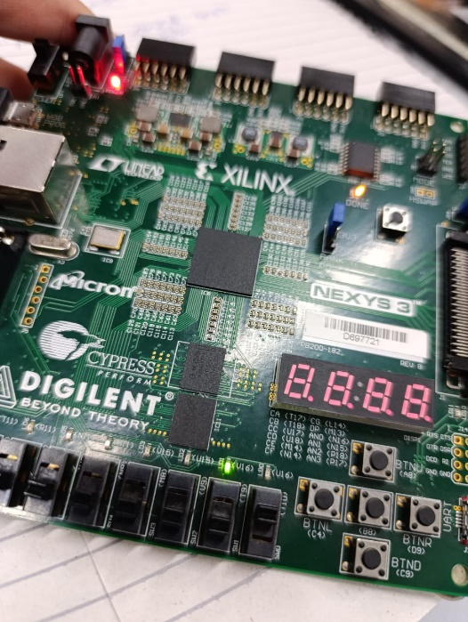

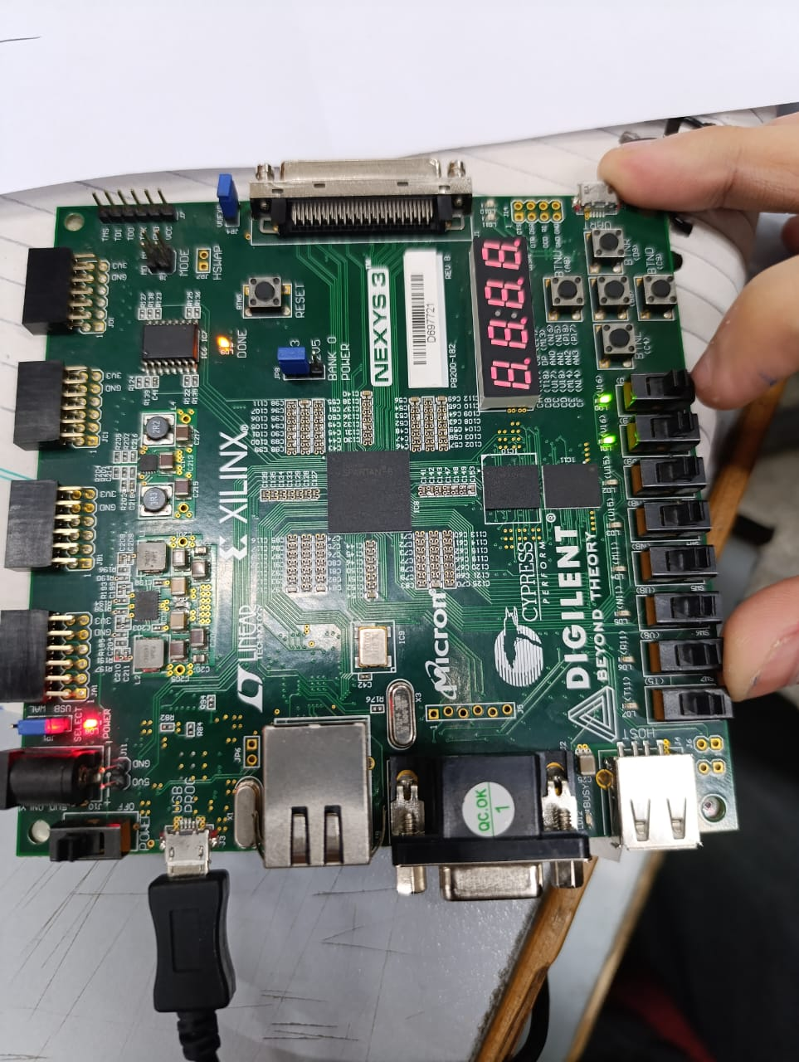

**2.** Lab Task: Write the code to toggle 4 LEDs with the use of 4 buttons and use different variable for each of the led and button.

**Solution**

Verilog Code:

module four_leds(

input [3:0] in,

output [3:0] out

);

assign out[0] = ~in[0];

assign out[1] = ~in[1];

assign out[2] = ~in[2];

assign out[3] = ~in[3];

endmodule

UCF:

NET "out<0>" LOC = "U16";

NET "out<1>" LOC = "V16";

NET "out<2>" LOC = "U15";

NET "out<3>" LOC = "V15";

NET "in<0>" LOC = "T10";

NET "in<1>" LOC = "T9";

NET "in<2>" LOC = "V9";

NET "in<3>" LOC = "M8";

**FPGA:**

